# Functional Requirements Document (FRD)

Project Title: Portfolio Insights & Risk Dashboard — Hedge Fund Trades

Prepared By:Business Analyst

Date: October 2025

Version: 1.0

## 1. Introduction

This Functional Requirements Document (FRD) translates the BRD into detailed specifications. The development approach follows a hybrid model: Waterfall for initial planning and Agile Scrum for implementation (2-week sprints).

## 2. Functional Specifications

The system shall compute the total portfolio value and related performance metrics.  
  
  
Key Functions:  
- ETL ingestion from CSV to SQL warehouse.  
- Compute ROI, Value-at-Risk, and P&L daily.  
- Provide BI dashboards for fund managers.  
- Role-based authentication for report access.

## 3. Non-Functional Requirements

- Performance: SQL queries must execute in under 5 seconds for datasets up to 50k rows.  
- Reliability: Fault tolerance achieved through automated backups and retry logic.  
- Availability: 99.5% uptime required.  
- Security:Data encryption in transit and at rest.

## 4. Use Case Specifications

Use Case 1: Generate Report  
- Actor: Fund Manager  
- Preconditions:Data ingested successfully.  
- Basic Flow:Login → Select Portfolio → Run Query → View Metrics  
- Postconditions:Report generated and displayed.

## 5. UML Diagrams

Use Case Diagram:

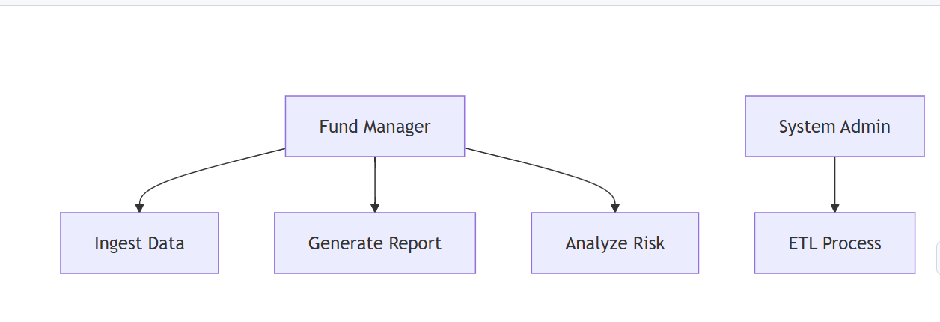

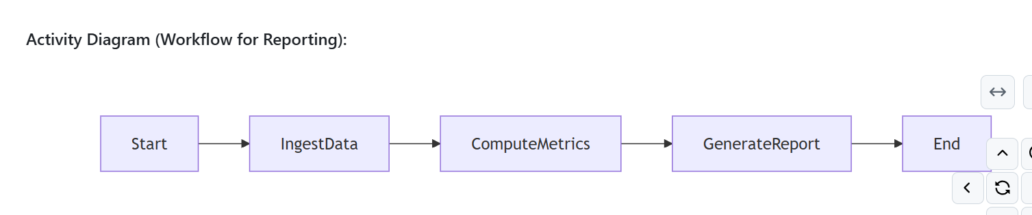

## 6. Methodology

The system development follows RUP/UML standards. Agile methodology ensures continuous stakeholder feedback, while Waterfall milestones (Requirements, Design, Build, Test, Deploy) provide structured delivery. Each sprint will cover ETL enhancements, dashboard updates, and performance testing.

## 7. Answers / Analysis

UML diagrams ensure clear workflow understanding among developers and stakeholders. Agile sprints allow iterative feedback loops for rapid enhancement and risk mitigation.